**Roll no: 19P-0104**

**Name: Ibrar Babar**

**Section: B**

**Lab no. 1**

* ipconfig

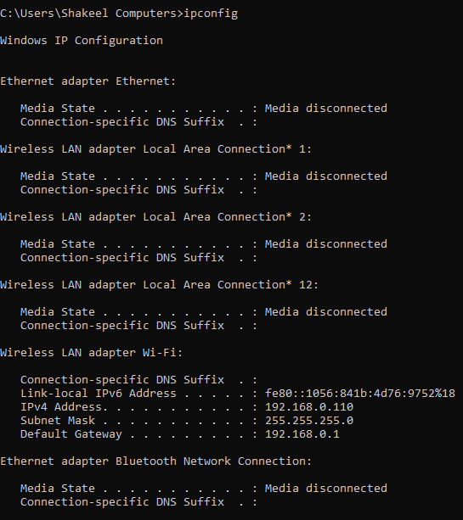

* ipconfig /all

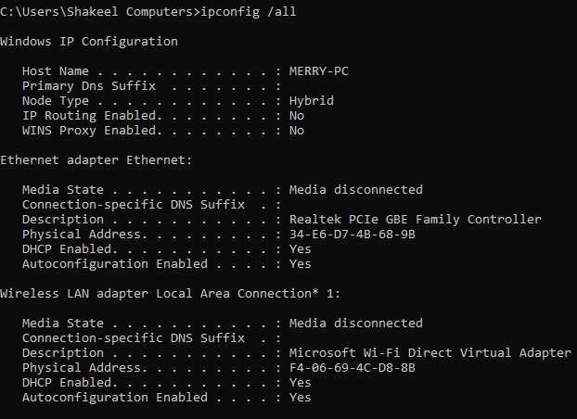

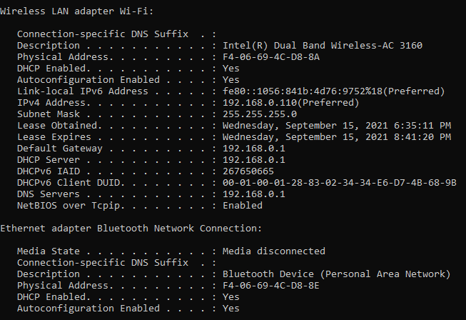

* ipconfig /release

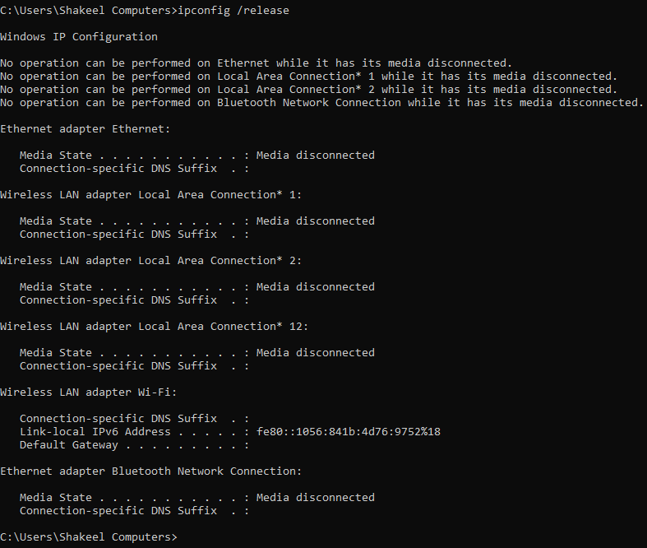

* ipconfig /release Wi-Fi

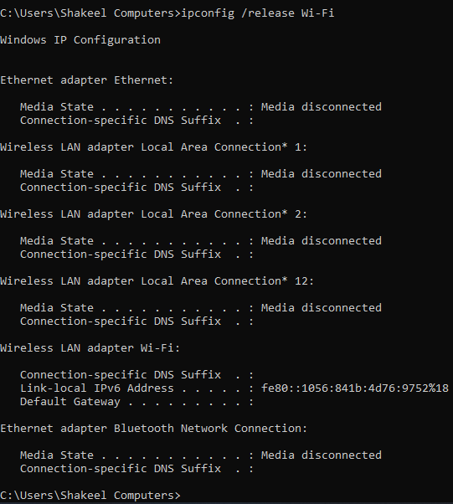

* ipconfig /release6

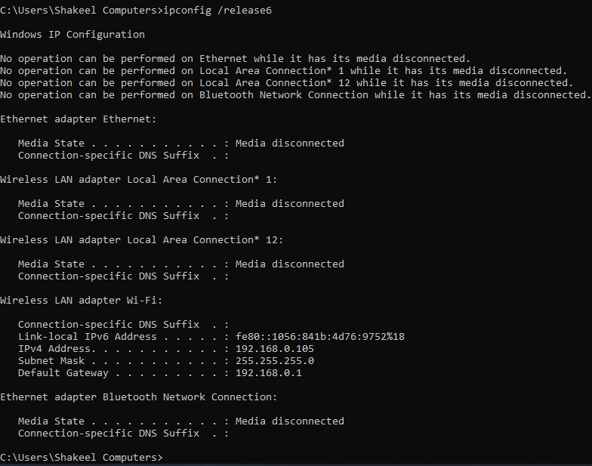

* ipconfig /renew

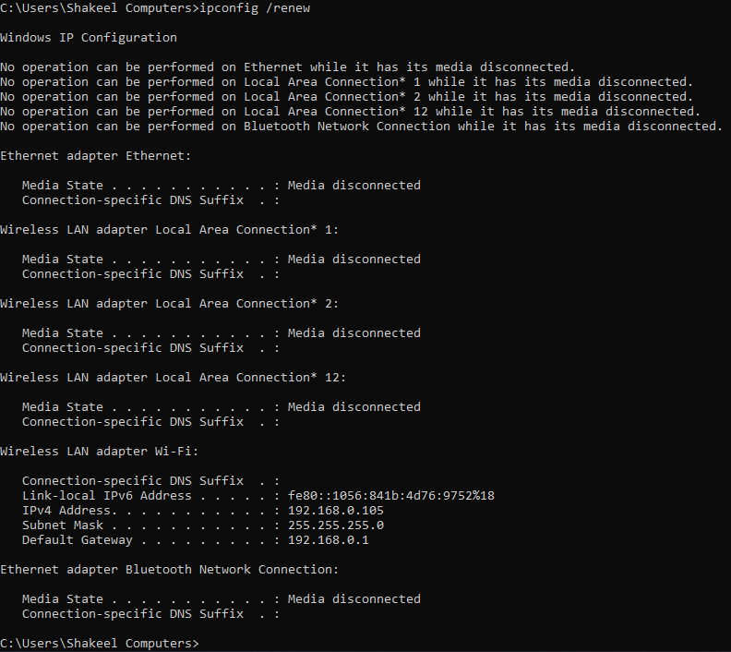

* ipconfig /renew6

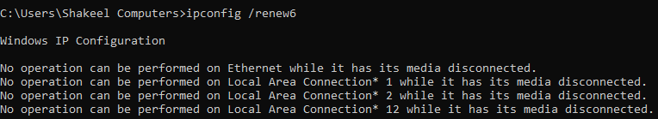

* ipconfig /all | findstr /v 00-00-00 | findstr Physical

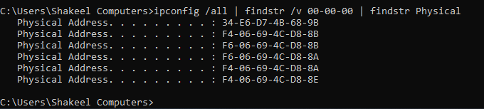

* ipconfig /all | findstr v4

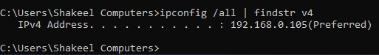

* ipconfig /displaydns

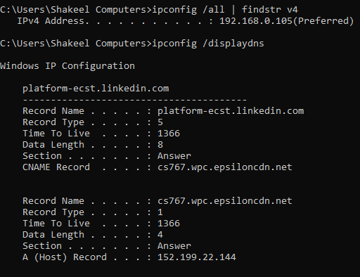

* Ipconfig /flushns

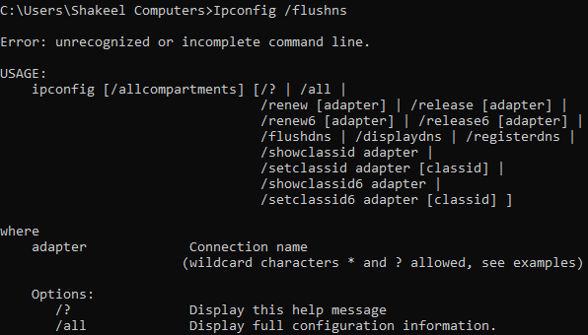

* Ipconfig/?

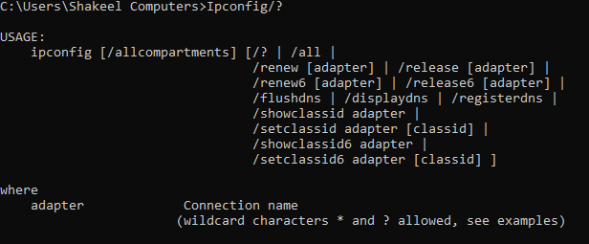

* Ipconfig/? >D:\ipconfig-result.txt





**(inside txt file the data is…..)**

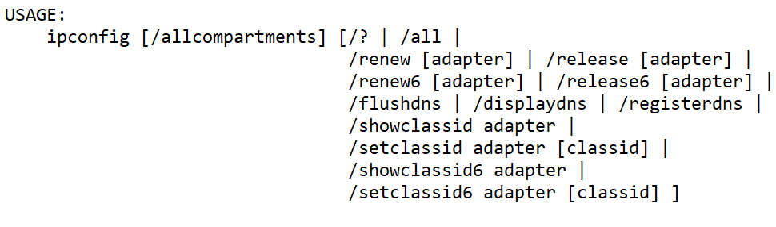

* nslookup google.com

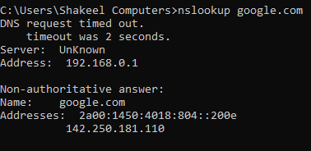

* nslookup 142.250.181.110

